*No part of this publication can be reproduced, transmitted, transcribed, stored in a retrieval system, or translated into any language, in any form or by any means, electronic, mechanical, photocopying, recording, or otherwise, without prior written permission from ShieldWatch*

www.shieldwatch.com

USA Corporate Office   
4014 Gunn Highway, Suite 248

Tampa, FL 33618, USA

Phone: (813) 490-4260

Email: sales@shieldwatch.com

India Development Center  
Merlin Infinite, Office #609, 6th Floor,

DN 51, Sector - V, Salt Lake City,

Kolkata - 700 091, West Bengal, India

Phone: +91 (033) 6615 7418

Email: marketing@shieldwatch.com

Doc Name: SRS Document–Advanced Micro Solutions 1099 etc webservice

Version: 1.0 | Date: April 27, 2016





**Table of Contents**

**SOFTWARE REQUIREMENT SPECIFICATION**



DEVELOPMENT | DESIGN | MARKETING

1 Introduction 3

1.1 Document Information 3

1.2 Point of Contacts 3

1.3 Introduction to Shieldwatch 3

2 Project Requirement 4

2.1 Overview of the Project 4

2.2 Proposed System 4

2.2.1 Process Flow for the Proposed Application 5

2.2.2 Sample Screens 7

2.3 Challenges 9

2.4 Milestone Breakup, Delivery Plan and Quality Analysis Plan 9

2.5 User Interface Design Standard 10

2.6 Deployment Planning 10

# Introduction

## Document Information

|  |  |  |
| --- | --- | --- |
| **Document Version** | | 1.0 |
| **Prepared For:** | **Advanced Micro Solutions** | |
| **Prepared By:** | | |
| **Name** | **Role** | **Date** |
| Sougat Hajra | Associate Director - Operations | 27th April, 2016 |

## Point of Contacts

|  |  |  |  |
| --- | --- | --- | --- |
| **Name** | **Email** | **Skype** | **Phone** |
| Pratik RoyChowdhury  *CEO, Shield Watch* | [PRoychoudhury@shieldwatch.com](mailto:PRoychoudhury@shieldwatch.com) | mylatch | +1 813 481 8525 |
| Kausik Sarkar  *MD, Shield Watch* | [KSarkar@shieldwatch.com](mailto:KSarkar@shieldwatch.com) | kausik_acumen | +1 813 2007229 |

## Introduction to Shieldwatch

Shieldwatch Infotech Pvt. Ltd. is a team of dynamic IT professionals who share their passion for coding and technology. Established in the year 1998, in one of the premier Software Technology Parks of India, Kolkata with its headquarter at Tampa Bay Area, USA, Shieldwatch is known for its successful software/web projects and a satisfied clientele across the USA, Europe, Australia and Asia.

From critical web solutions to interactive mobile applications and online marketing, our business solutions are developed from scratch by centering our efforts on people-centric insights and collaboration. Shieldwatch specializes in providing a wide range of web services that includes software application, web-application, mobile application development, web marketing (SEO) and web-hosting.

**What Shieldwatch stands for:**

* 91% Customer Retention over 17 Years
* 94% Customer Satisfaction Rating over 17 Years
* 24/7 Phone Support
* Agile Approach
* Project management system with date tracking & Live Updates
* Transparent Methodology
* Proven Industry Standards
* Prompt After-sales Support

# Project Requirement

## Overview of the Project

**Advanced Micro Solutions (AMS)** **Payroll Software** is an add on module to the W-2/1099 Forms Filer. This allows payroll and non employee compensation and certain other 1099 information to be entered by check throughout the year. The program supports either “**Live**” or After-The-Fact Payroll. Through our payroll software you can transfer this data to the state/federal quarterly unemployment forms along with the year end W-2s and 1099s.

Some Features available in this system:

* Processes “Live” or After-The-Fact Payroll.
* Exports data to the W-2/1099 Forms Filer for year-end processing. The **E-Filer will electronically file your year-end W-2 and 1099 forms to the IRS/SSA.**
* Creates an SSN Verification file.
* Electronically file 941, 944, and 940 forms.
* Automatically calculate federal, state and local payroll taxes.
* Processes Employee Direct Deposit payroll information.

Currently, the AMS Payroll Software performs the E-Filer Operations through one 3rd party application. There are several shortfalls in this process and that is why AMS is planning for the development of a New Tools for their own. This New Tool will help to perform the **E-Filer** Task to the **Internal Revenue Service (IRS) and Social Security Administration (SSA)** Site.

## Proposed System

Shield Watch is responsible for developing a Platform which will work as the bridge between the AMS Payroll System and IRS & SSA.

Individuals or Institutions need to submit their Financial Statements and Social Security Statements to the IRS and SSA System respectively. These information can be submitted electronically to those Applications. For this there are a number of different Forms available in predefined formats. These information can be submitted online through **Secure WebService Calls.** Data to be submitted to the respective IRS and SSA System through specific XML Data Formats. Following are the list of such XML Formats:

* Form/XML format for the IRS System:
* 1099-A
* 1099-B
* 1099-C
* 1099-CAP
* 1099-DIV
* 1099-G
* 1099-INT
* 1099-LTC
* 1099-MISC
* 1099-OID
* 1099-PATR
* 1099-Q
* 1099-R
* 1099-S
* 1099-SA
* 5498
* 5498-ESA
* 5498-SA
* 1098
* 1098-C
* 1098-E
* 1098-T
* 940
* 941
* 944
* Form/XML format for the SSA System:
* W-2
* W-2C
* W2-G
* Additional Forms/XML Formats for the IRS System:
* 1094-B
* 1095-B
* 1094-C
* 1095-C

### Process Flow for the Proposed Application

Proposed Application will be developed for Web. The Application will be hosted in Cloud. This Application will hold one Centralized Database. AMS Payroll Software are installed in different Personal Computer (PC)s, Laptops and are located at different locations. AMS Team will develop tool which will generate data in XML Format and the same will be uploaded to the Cloud System. Uploaded Data will be processed and stored in the Database of the Cloud System.

Cloud System will have one Control Panel. This Control Panel will run Securely under SSL Protocol. This system will have secure login section. Different Admin Users can access the system. Each User can have different levels of access control. There will be one Super Administrator, who will have access to all the sections. This Super Administrator will be able to manipulate access control system.

Cloud System will process the data uploaded from the AMS System and then develop XML Data of the aforesaid formats. These XML files will then be pushed to the IRS and SSA System.

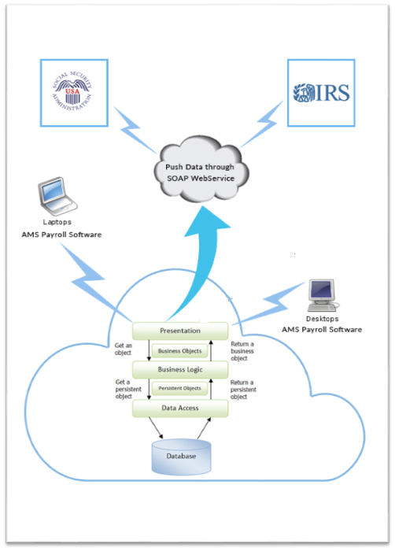

There will be Customer’s Section in this Cloud based Admin Panel. AMS Admin Users will have access to manage the customer information. Clients will be able to track the status of the data submitted through this system.

### Sample Screens

Below Sections will show list of some Sample Screens. In the proposed application data will be changed as per the data for the application.

#### AMS Admin Users

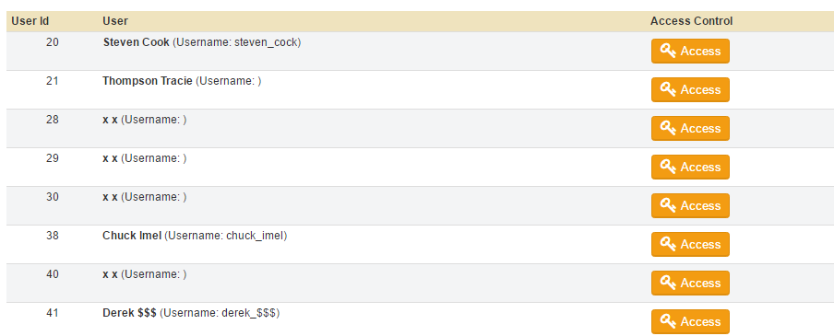

#### AMS Admin User Access Control

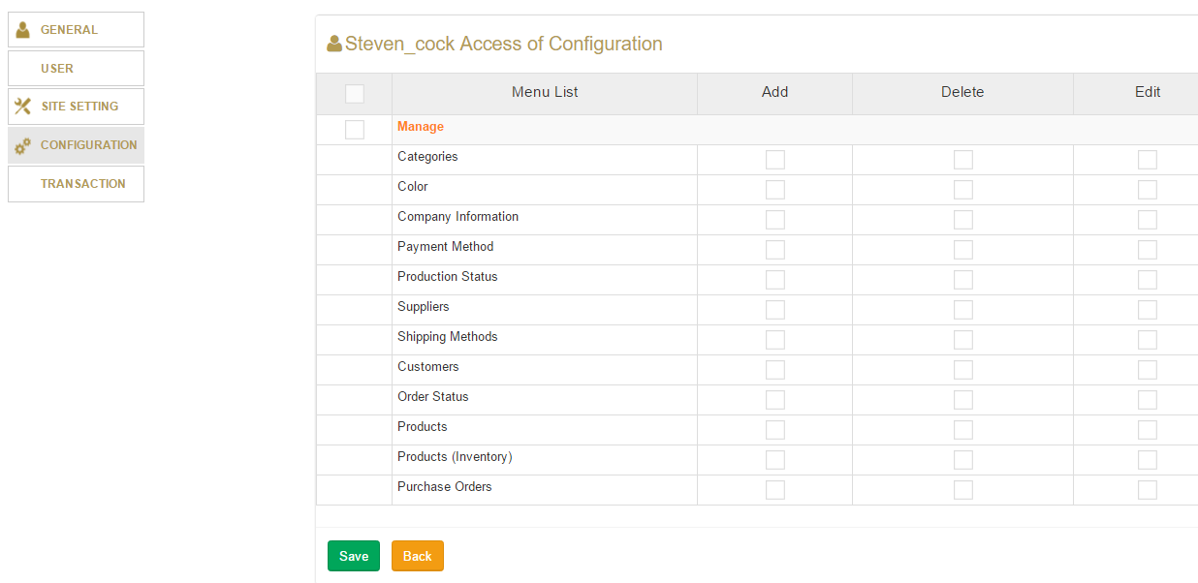

#### Dashboard

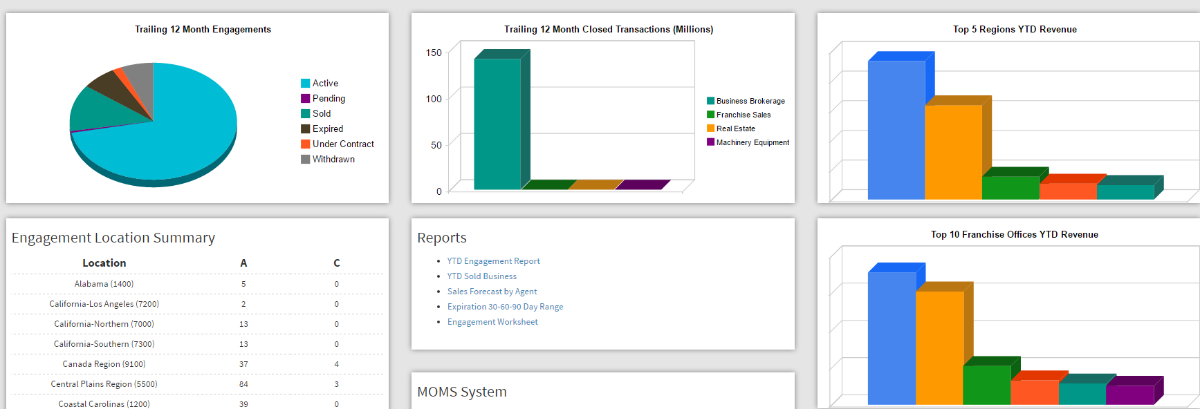

#### Reports

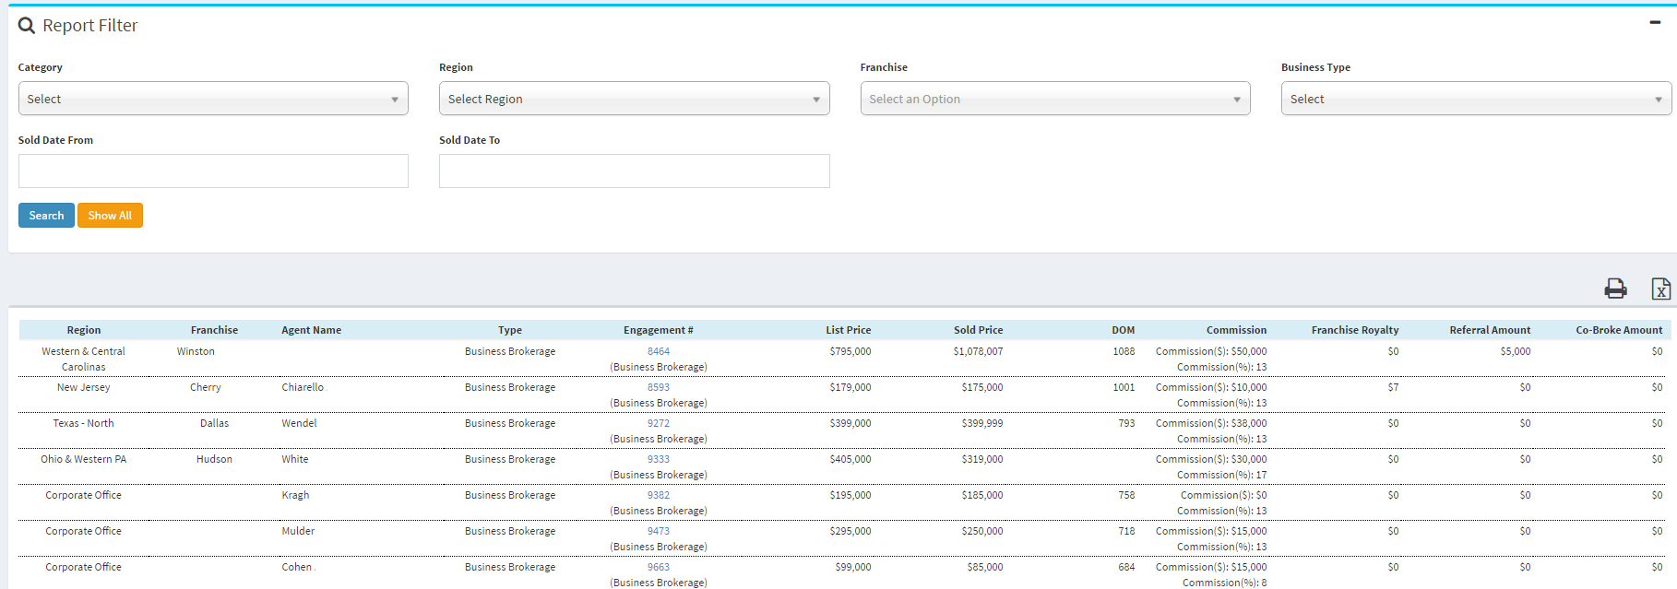

#### Add/Edit Interfaces

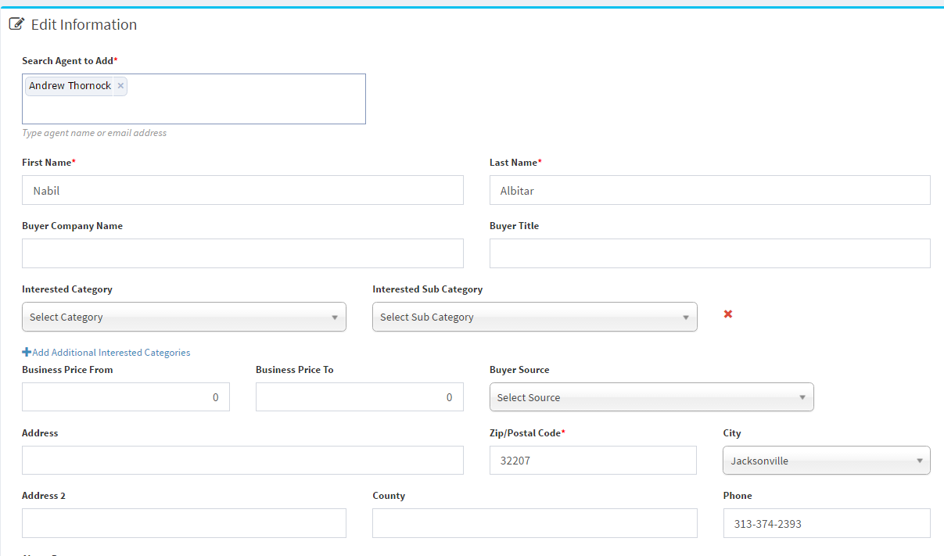

## Challenges

At this moment we can estimate following challenges to be taken care of.

* Identify each and every elements from the Data uploaded in the System.
* Create XML Files based on the data and the prescribed formats.
* Research on how to process the data to the IRS and SSA System.

## Milestone Breakup, Delivery Plan and Quality Analysis Plan

Following milestones will be covered during the whole cycle of the project.

* Requirement Analysis and System Design:
* User Interface (UI) Mockup Design:
* Database Design:
* Application Development:
* Quality Analysis and Bug Fixing:
* Cleanup Test Data and Migrate/Upload Live Data:
* Deployment, Post Deployment Testing:

Communications will mostly be carried out through ActivCollab (Project Collaboration Tools). There are provisions for creation of Tasks and Discussions through which these communications can be taken care of. Additionally Documents and other Resource files and Credentials can be stored here.

Weekly updates will be given at the end of every week usually. Again at the end of every milestone, overall milestone updates will be given.

GotoMeeting will be used to schedule online meeting.

Development will be done at Shieldwatch Server. There will be QA phase on every Milestone released for Testing. All defects will be logged in Mantis (Bug Tracking Tool) which is hosted at Shieldwatch’s Server. Both Shieldwatch and Client will have to provide their Feedbacks/Test Report in Mantis within some stipulated timeline. Shieldwatch Team will address the Bugs/Feedbacks on that Specific Milestone. All Change Requests will be recorded in another Change Request Log System. Once the QA Process is over against each Module/Milestone, then the same will be considered as complete. After completion of all the of the Modules/Milestones, system integration Testing will be performed by Shieldwatch. Also Client will need to provide their feedbacks by specified time. This testing will ensure that, all Applications and Tools are properly connected and tested.

Necessary Test Data will be added in the system to check the UI functionality and

Any specified timeline may vary +/- (10% -- 20%) based on different unknown or unidentified risks or factors.

## User Interface Design Standard

After Analysis Phase is over, Team will create Mockup Design for the project. Mockup will be designed using Adobe Photoshop. All different/important Screens will designed, including Home Page, Category Listing, Product Details, Contact Us, Content Based Page etc.

After mockups are finalized, UI Team will start working for HTML Coding. Site will be run on all latest versions of all popular browsers such as Chrome, FireFox, Safari and Internet Explorer. Also site will open in Browsers under Mobile Devices (Smart Phones and Tabs/Ipads).

## Deployment Planning

Once the System Integration Testing is completed, all applications can be hosted in the Production server. There will be one round of Testing the Development Server to ensure that, all functionalities are working fine as expected. After completion of this, all Test Data will be cleaned from the System.

Client will have to arrange actual Contents, Images, Category & Product Data and other relevant information, which will be uploaded to the Application.

We propose two version of the application to run parallel. First one will be the staging version and the second one will be the Live Version. Post Deployment Stage, all work will be first uploaded in the Staging Server for review and testing. Once approved, those changes can be released in the Live Server. For Staging, separate Physical Machine is not required. Any Virtual Server may be used for this purpose.